Welcome to Artgalerie


Welcome to ARTGALERIE

The dedicated platform for buying and selling unique art pieces.
Our goal is to connect artists and galleries directly with a global audience of art enthusiasts.

By registering, you gain access to a powerful e-commerce environment designed to maximize your visibility and sales.

The site features a clean and elegant layout, ensuring a premium shopping experience for customers as they navigate through the categories and search for products.

Artist Account

Artist Account
Step 1: Navigate to the Website

Please go to our official platform URL: https://artgalerie.com.br
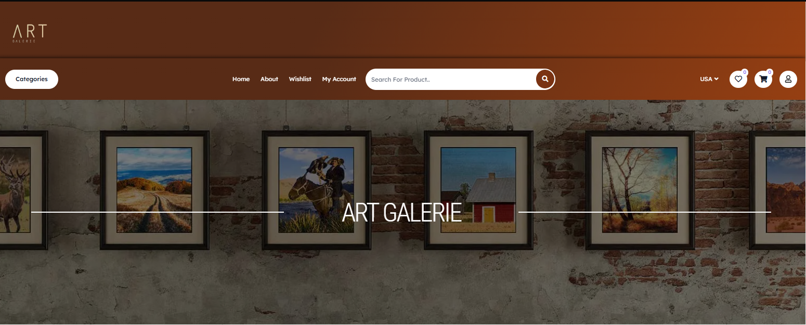

Step 2: Locate the Account Icon
Click on the "My Account" icon (represented by the user silhouette) located in the upper right-hand corner of the page, next to the Wishlist and Shopping Cart icons.
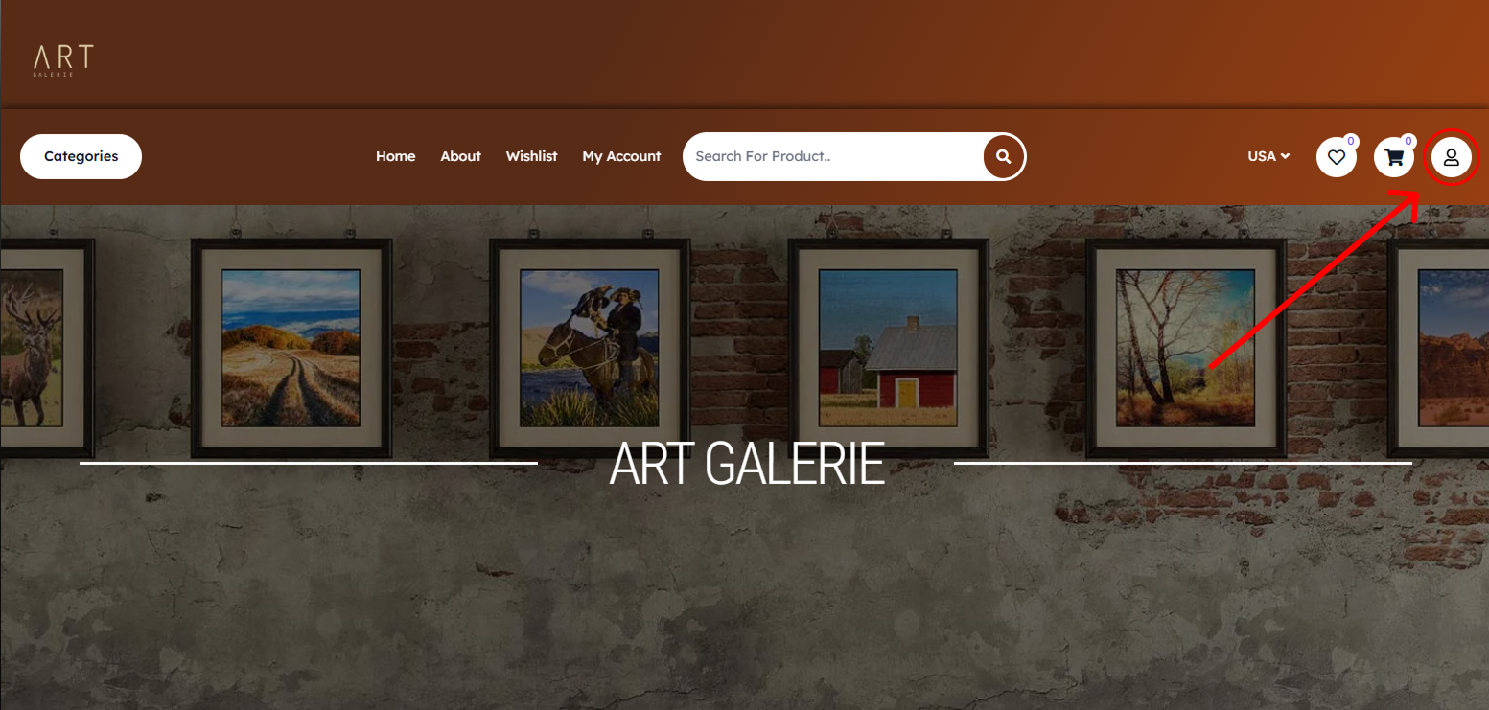

Step 3: Login or Register
This action will open a new tab, directing you to the login area at https://artgalerie.com.br/my-account.

If you already have an account: Enter your Username or email address and your Password in the designated fields, and then click the "LOG IN" button to proceed.

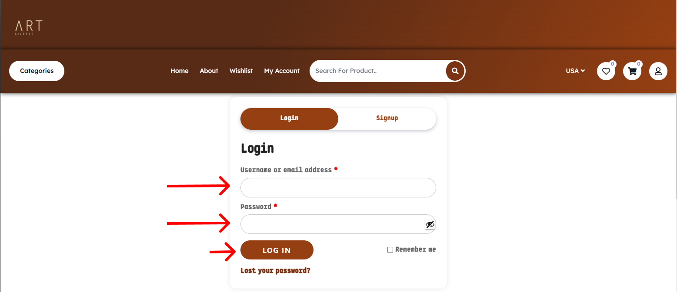

If you are a new user: Click the "Signup" tab to create a new account.

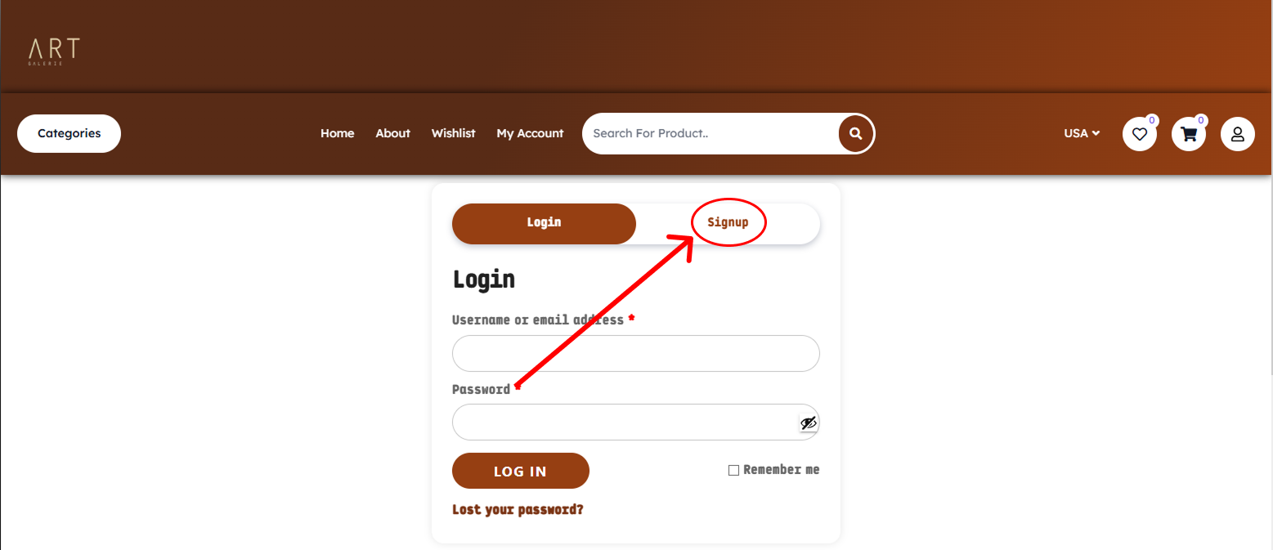

and complete the necessary details to finalize the artist/seller registration.

Business Info
Once your seller profile is successfully created, you will be guided to the initial store setup page. This stage is crucial for us to understand your business and tailor your experience on the platform.

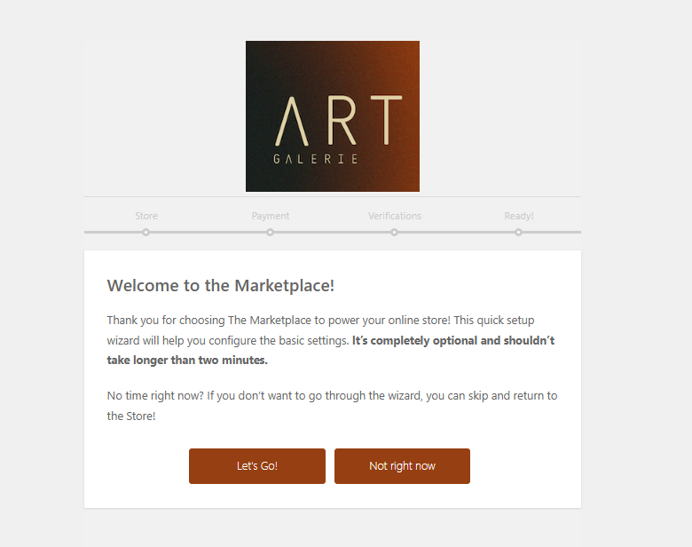

Store Setup: Basic Information
To establish your presence on ART GALERIE, please fill in the following details accurately. This information will be used for both operational purposes and display on your storefront.
- Enter Your Store Address:
  - Fill in your primary address details in the Street and (optional) Street 2 fields.
  - Provide your City and Post/Zip Code*.
  - Select your Country from the dropdown menu and enter the State name.
- Email Visibility:
  - By default, your email is kept private. If you wish to display your contact email address on your public storefront, check the box next to "Show email address in store".

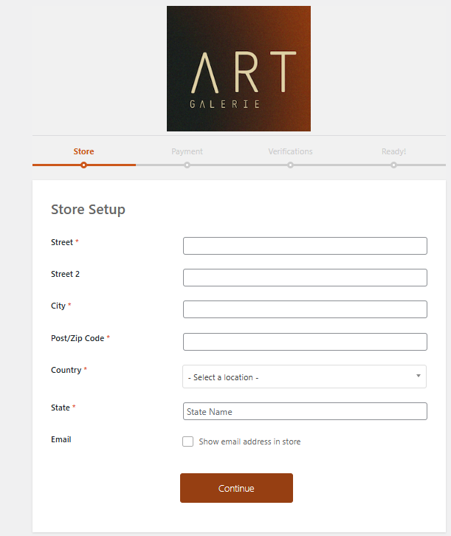
- Continue Setup:
  - After reviewing the information, click the "Continue" button to proceed to the Payment setup stage.

Conectar Payment

Stripe Account

To ensure secure and efficient processing of your earnings, you must link your store with a Stripe account. Click the button to be securely redirected to the Stripe platform and authorize the connection. If you don't have a Stripe account, you can create one during this process.
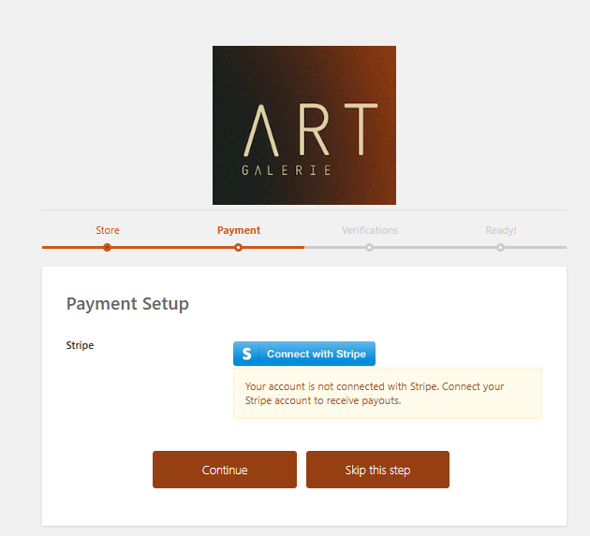

Upon completion, you will be redirected to the platform's Dashboard.
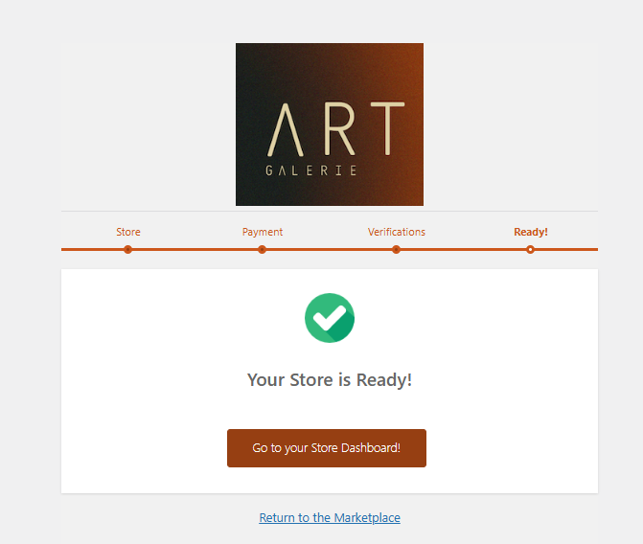

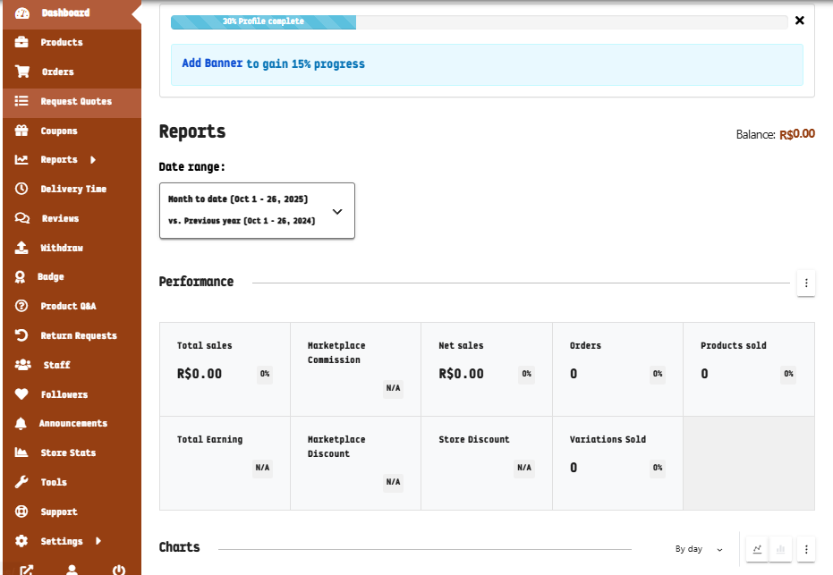

Alternative Payment Setup via Dashboard

If the Stripe connection is unsuccessful during the initial setup, please attempt to connect your payment account through the Seller Dashboard.
Step 1: On the left-hand column of the Dashboard, click 'Settings'."
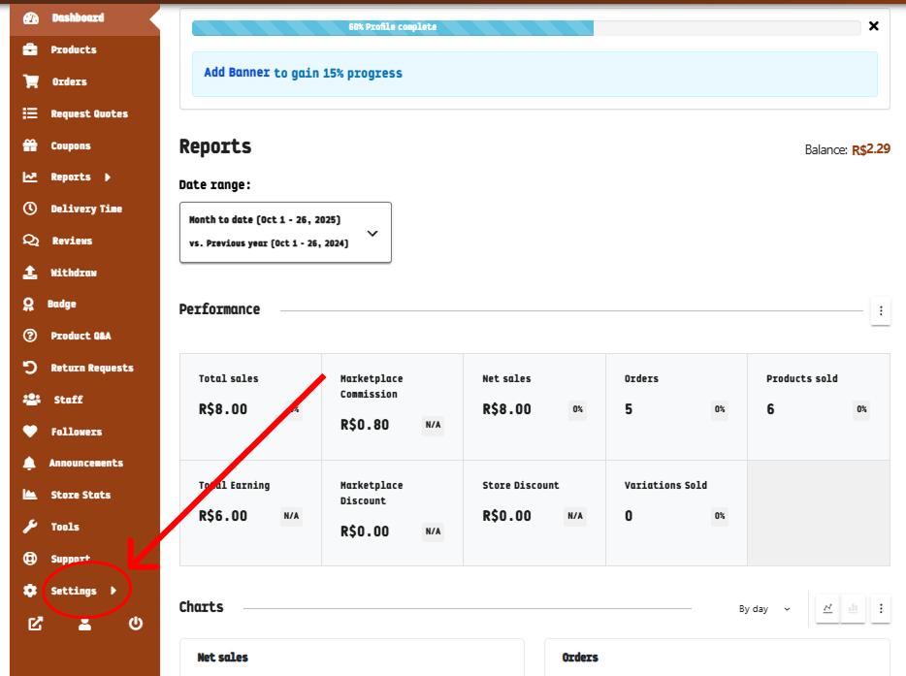
Step 2: Click “Payment’:
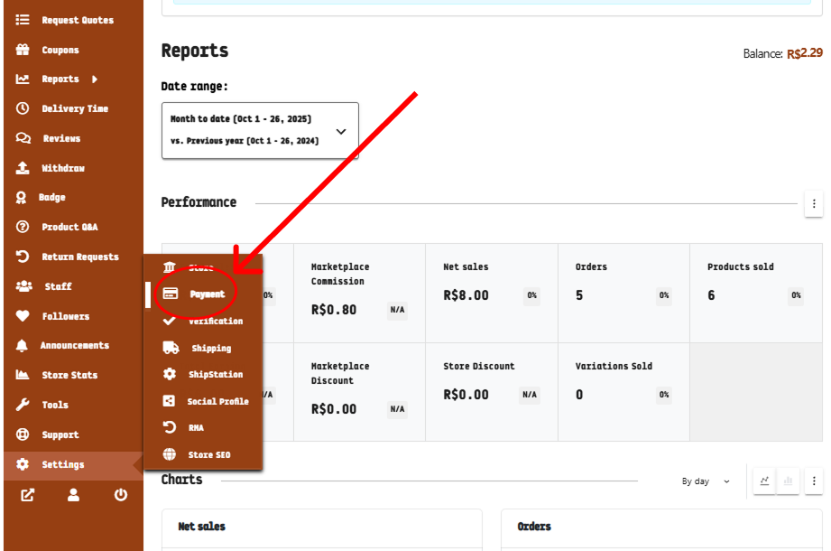

Step 3: On the right panel, access the payment methods. Select 'Stripe' as the preferred payment method, as shown below.

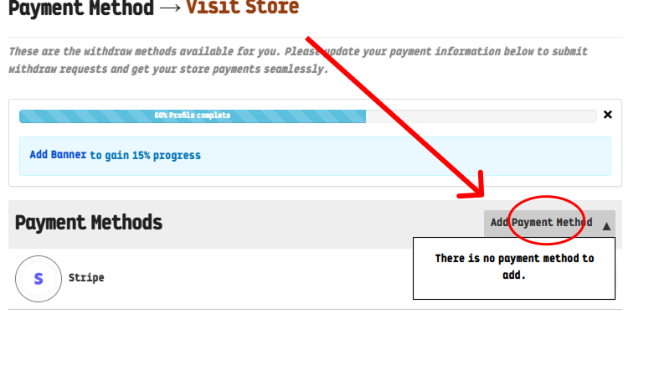

Create Products

Create Products

To list your artwork and make it available for sale, follow these steps:
- Navigate to the left sidebar menu and click on the 'Products' section.
- On the right side of the screen, click the 'Add New Product' button.

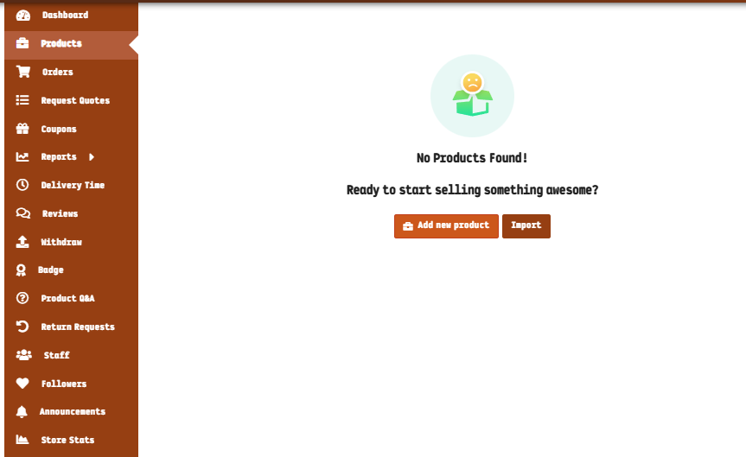

Product Information Input
This is where you will provide all the necessary details to inform your customers and drive sales. You will be able to input key product information, such as:
- Pricing and Inventory: Set the price and specify the available units (stock).
- Media: Upload high-quality images and/or videos of the artwork.
- Categorization: Select the appropriate category and add relevant tags.
- Description and Details: Provide comprehensive descriptions, including size, weight, and any unique features.
- Promotions: Configure special offers or discounts, if applicable.

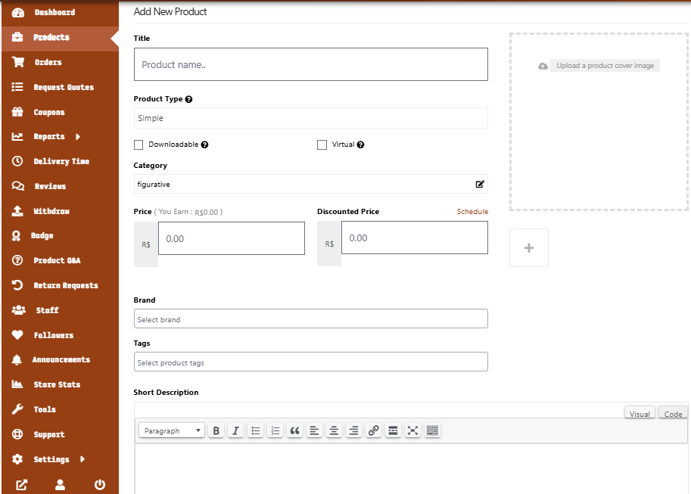

Review and Approval Process
Once you have completed and saved your product details:
- Your listing will enter a 'Pending Review' status.
- The product will wait for the marketplace team to approve it and publish it to the store.
- This approval process typically takes up to 24 hours.

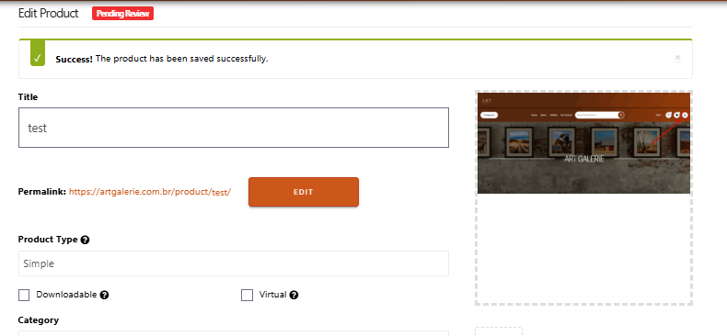

Going Live
- Upon successful approval, your product status will change.

- You will see your artwork listed as online and ready for sale on both your individual storefront and the main marketplace.

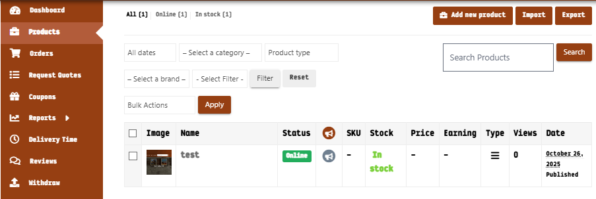

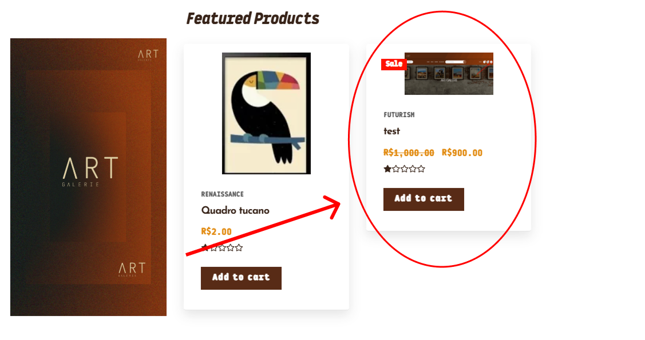

Orders

Orders

In the Orders section, you will be able to view and track all customer requests. This area provides comprehensive details for each order, including the total values, the amount you are scheduled to receive, and the customer who placed the request

